MirrorSpace: New Direction Report
Sep 29, 2026 · @Anuurag
MirrorSpace becomes a mobile app that does for mental health what Co-Star did for astrology: a daily, personal, beautifully sparse reading — except every line is built from the user's own sleep, body and writing signals, not the stars.

1. Positioning
Thesis: Co-Star's readings are fiction written to sound precise. MirrorSpace's are real data written to sound like poetry. Co-Star's line comes from the stars; MirrorSpace's comes from sleep, heart-rate variability, calendar load, phone rhythm and how the user writes. Every reading can show its receipts.
 | Co-Star | MirrorSpace
Input | Birth date, time, place (once) | Passive phone and wearable signals, one-tap check-ins, voice and text venting
Daily output | Horoscope line and Do/Don't list | Mind reading and Do/Don't list built from the user's own patterns
"Chart" | Natal chart, fixed for life | Mind Chart: chronotype, stress signature, drains and restorers, updated as the user changes
Social | Friend compatibility by sign | Rhythm compatibility, low-battery signal, check-in circles
Truth claim | None (entertainment) | Every insight traceable to data ("Why am I seeing this?")
Tone | Blunt, cryptic, sparse | Observational, calm, sparse; never clinical, never diagnostic
Who it is for (launch segment): adults 18–30 who already use Co-Star, Daylio, Finch or Stoic, who feel "off" without knowing why, and who will not open a clinical-looking app. Secondary: people in therapy who want a record of the weeks between sessions.
What it is not: a therapist, a diagnostic tool, or a meditation library. That line is both a brand choice and a legal one (see section 8).
What already exists in the repo and carries over: the personality prompt ("a quiet room, not a clinic"), delayed vent reflections, the daily insight, voice chat, sleep logging, calm mode and the pattern engine. The web client (React + Vite) becomes the design reference for the mobile app; the Express server is refactored rather than rewritten.

2. Market landscape (September 2026)
No app combines Co-Star's taste and social loop with evidence-based, passive mental-health insight. Meditation apps have content but little personalisation. AI companions talk but don't observe. Trackers observe but demand effort and look like spreadsheets.
App | Category | What it ships | Price | Gap MirrorSpace fills
Co-Star | Astrology, social | Daily push line, Do/Don't, birth chart, friend compatibility, paid "Void" questions; ~4.3M MAU; acquired by Midjourney in 2026 | Free; Pro-Star $8.99/mo (source) | Content isn't grounded in anything real; no wellbeing layer
Headspace + Ebb | Meditation + AI companion | Meditation library, sleep, Ebb AI (voice mode, memory, motivational interviewing), therapy/coaching, crisis escalation | Subscription | Library-first; little passive sensing; generic wellness look
Calm | Meditation, sleep | Sleep stories, meditations, AI-personalised recommendations | Subscription; users complain of price (source) | Content, not insight; nothing social
Wysa | CBT chatbot | Rule/AI chatbot, CBT exercises, human coaching, SOS | Freemium | Clinical tone; user must type
Woebot | CBT chatbot | Consumer app shut June 30, 2025 after FDA cost; pivoted to enterprise | — | Shows the risk of positioning as therapy
Ash (Slingshot AI) | AI therapy | Therapy-trained LLM; $93M raised; 150k+ users; pulled from UK Jan 2026 (source) | Free for now | Therapy framing blocked in several states; chat-only
Rosebud | AI journaling | Interactive journaling, voice, long-term memory, weekly reports, IFS templates, encryption | Free; $12.99/mo | Requires writing daily; no passive data; no social
Stoic (YC S19) | Journal + mood | Morning/evening check-ins, prompts, trends, AI mentors, breathing | Freemium | Busy UI; engagement depends on routine
Daylio | Micro-diary | Icon mood logs, activities, Year in Pixels, correlations | Freemium | Manual, spreadsheet-like insight
Bearable | Symptom tracker | Mood/symptom logs, correlation "Impacts", health-data imports, weekly reports | Freemium | Built for chronic illness; dense UI
How We Feel | Emotion check-in | Yale Mood Meter with 144 emotion words, strategies, sleep/exercise trends; nonprofit, no ads | Free | No AI reflection, weak habit loop
Finch | Gamified self-care | Virtual pet, goals, friends ("Tree Town", good vibes); ~$2M/mo revenue (source) | Free; Finch Plus £70.99/yr | Childlike aesthetic; streak pressure
Apple Health | OS-level | State of Mind logging, PHQ-9 and GAD-7 risk screens, life-factor links; on-device | Free | No interpretation, voice or social layer; iOS only
Market facts that shape the plan
- A median of about 70% of users drop a mental health app within 100 days (source); median 30-day retention was 3.3% across popular Android mental health apps in the independent Baumel 2019 panel (JMIR). Retention is the unsolved problem.
- Price is the top complaint about Calm, Headspace and BetterHelp. Users see premium pricing for mental health as unethical.
- Co-Star's move under Midjourney leaves its design-literate audience without a clear home for a daily "reading" ritual.

3. Research foundations
Each core mechanic rests on peer-reviewed evidence, but the effects are small to moderate. MirrorSpace should claim awareness and reflection, never treatment. The evidence also says what to avoid: long programmes, heavy manual logging and unsupervised "therapy" claims.
Mechanic | Evidence | Design implication
Naming feelings (affect labelling) | Labelling an emotion reduced amygdala response and raised right ventrolateral prefrontal activity in an fMRI study (Lieberman et al., 2007, Psychological Science) | Check-ins offer a rich emotion vocabulary, not just a 1–5 face scale
Self-monitoring builds emotional self-awareness | Mood self-monitoring on phones raised emotional self-awareness in young people with early depressive symptoms (Kauer et al., 2012, JMIR); engagement with a self-monitoring app predicted mental-health change (MoodPrism, J Affective Disorders) | The one-tap check-in is the core habit; insight reflects it back
Expressive writing | 146-study meta-analysis found a small positive effect (r ≈ .075), larger with more and longer sessions and directive prompts (Frattaroli, 2006, Psychological Bulletin); later meta-analyses are mixed outside PTSD (European Psychologist review) | Vent is optional and prompted; don't oversell it
Passive sensing (digital phenotyping) | 14 studies (3,249 people) predicted depression severity from phone GPS, mobility, phone use and sleep with moderate accuracy; missing data and no external tests are the main limits (systematic review, Neurosci Biobehav Rev, ScienceDirect); combining passive data with brief self-report works best (Korean community study, ScienceDirect) | Passive signals plus one tap a day; personal baselines, not population models
Sleep and circadian rhythm | Sleep-wake data from wearables predicted next-day depressive episodes with AUC 0.80; circadian phase delay was the strongest predictor (Lim et al., 2024, npj Digital Medicine) | Sleep timing (not just duration) is a first-class signal in the reading
Right-moment nudges (JITAI) | Just-in-time adaptive interventions show a small effect (g = 0.15), lasting up to 6 months; shorter programmes (<6 weeks) held effects better (2025 meta-analysis) | Nudges only when signals shift; short 7-day experiments instead of long courses
Generative-AI support | First RCT of a generative AI therapy chatbot (Therabot, n = 210) cut depression, anxiety and eating-disorder symptoms vs waitlist over 4 weeks (Heinz et al., 2025, NEJM AI); critics flag the waitlist control and lack of independent evaluation (NEJM AI letter) | Keep AI reflective and supervised by safety layers; don't claim therapy outcomes
Engagement decay | Median 15-day retention 3.9% and 30-day 3.3% across mental health apps; peer-support and tracker apps retained best (Baumel et al., 2019, JMIR) | Social layer and tracking are the two retention levers; breathing-only features retain worst
Evidence to generate ourselves: run a pre-registered 8-week pilot (for example with a university counselling centre) measuring emotional self-awareness and WHO-5 wellbeing. Publishing it is both a moat and a B2B sales asset.

4. Parity features: what competitors already ship
43 table-stakes features, each redesigned in MirrorSpace's voice. Users switching from any app in section 2 should find nothing missing. Phase: MVP = first release, v1 = months 3–6, v2 = months 6–12.
Area | Feature | Already in | MirrorSpace version | Phase
Daily ritual | One daily push line at wake time | Co-Star | "Mind reading" from last night's sleep and recent patterns | MVP
Daily ritual | Do / Don't list | Co-Star | 3 Do's, 3 Don'ts tied to the user's own triggers | MVP
Daily ritual | Day-at-a-glance by life area | Co-Star | Inner Weather: Mind, Body, Social battery, Focus | MVP
Daily ritual | Ask a question (paid) | Co-Star Void | Ask the Mirror, answered from the user's data with citations | v1
Check-in | Mood check-in with emotion vocabulary | How We Feel, Apple Health | Energy × pleasantness grid with ~100 words, original layout | MVP
Check-in | Tags for what influenced mood | Daylio, Stoic, Bearable | Context tags (people, work, body, place), auto-suggested | MVP
Check-in | Morning and evening check-ins | Stoic, Rosebud | Optional; morning = reading, evening = one-tap close | MVP
Check-in | Smart reminders | All | Timed to the user's rhythm, never more than one a day by default | MVP
Journal | Free-text journal | All journaling apps | Vent: write, then let it go (optional save) | MVP (exists)
Journal | Voice journal with transcription | Rosebud, Ebb | On-device transcription; audio discarded by default | MVP (exists as voice chat)
Journal | Daily prompts | Stoic, Rosebud | One prompt a day chosen from recent patterns | v1
Journal | Guided templates | Rosebud (IFS), Stoic | Short templates: worry dump, gratitude, letter you won't send | v1
Journal | Photo attachments | Daylio, Stoic | Optional image per entry | v2
Journal | Search across entries | Rosebud | On-device full-text search | v1
AI | Conversational AI with memory | Headspace Ebb, Rosebud, Ash | Mirror chat: reflective, short, remembers patterns | MVP (exists)
AI | Voice conversation | Ebb | Voice mode on Mirror chat | v1 (exists on web)
AI | Weekly report | Rosebud, Bearable | Sunday "week in reflection" | MVP
Tracking | Sleep log | Calm, Bearable, Sleep Reset | Automatic from HealthKit / Health Connect; manual fallback | MVP (manual exists)
Tracking | Health-data import | Bearable, Apple Health | Sleep, HRV, resting HR, steps, cycle, daylight | MVP
Tracking | Correlations between habits and mood | Daylio, Bearable | Pattern engine v2 with personal baselines and lagged effects | v1
Tracking | Year in Pixels / mood calendar | Daylio, Bearable | "Year in Weather" mosaic, original visual form | v1
Tracking | Trend charts | Stoic, Bearable, Apple | Minimal line charts, one metric at a time | MVP (exists as Patterns)
Tracking | Cycle-aware insights | Bearable, Apple | Reads cycle data if shared; adjusts readings | v2
Calm tools | Breathing exercises | Stoic, Headspace | 3 patterns (box, 4-7-8, physiological sigh) | MVP (exists as Calm Mode)
Calm tools | Ambient / sleep sounds | Calm | Existing ambient sounds, offline | MVP (exists)
Calm tools | Grounding exercise | Wysa | 5-4-3-2-1 grounding, one screen | MVP
Calm tools | Short guided audio | Headspace, Calm | 10–15 short tracks only, no library | v2
Screening | PHQ-9 / GAD-7 questionnaires | Apple Health | Optional, informational only, shared only to the therapist export | v2
Safety | SOS / crisis button | Wysa, Headspace | Always-visible "Need help now" with local helplines | MVP
Safety | Personal safety plan | Clinical apps | Stanley-Brown-style plan the user fills in, one tap to open | v1
Social | Friends list | Co-Star, Finch | Add by contact or code; consent per friend | v1
Social | Send support | Finch (good vibes) | "Thinking of you" tap, no text needed | v1
Social | Compatibility | Co-Star | Rhythm compatibility (see section 5) | v1
Social | Shareable cards | Co-Star | Story-sized reading and chart cards | MVP
Care | Access to therapists or coaches | Headspace, Wysa, BetterHelp | Referral directory and therapist export (no in-house therapy) | v2
Platform | Home and lock-screen widgets | Daylio, Finch | Reading widget, one-tap check-in widget | MVP
Platform | Smartwatch app | Apple Health, Stoic | Watch check-in and breathing | v2
Platform | Offline mode | Daylio | Check-ins, vent and calm tools work offline, sync later | MVP
Platform | App lock (Face ID / PIN) | Daylio, Stoic | On by default suggestion at onboarding | MVP
Platform | Dark and light theme | All | Both, from day one | MVP
Platform | Languages | Headspace (expanding) | English first, then Hindi and Hinglish, Spanish | v2
Trust | Data export and deletion | Rosebud, Apple | One-tap export (JSON/PDF), one-tap delete | MVP
Money | Free trial, student discount | Rosebud, Finch | 7-day trial; student and low-income pricing | MVP

5. Differentiators: what no competitor combines
Twenty features in six groups, each aimed at a named gap in section 2. The moat is the combination: taste, evidence-backed receipts, a social layer built for bad days, and privacy by architecture.

Insight people can trust
Feature | Gap it fills | How it works | Phase
Receipts ("Why am I seeing this?") | Co-Star and AI companions give no basis for claims | Every reading links to the 2–3 signals behind it, e.g. "3 nights under 6h + entries 40% shorter" | MVP
Mind Chart | Trackers show data but no identity; Co-Star's chart is fixed | Unlocks on day 14: chronotype, stress signature, top drains and restorers, recovery speed, social-battery curve. Updates monthly | v1
Mind Forecast | Nobody warns before a dip | "Tomorrow looks heavy": short-term outlook from sleep timing, calendar load and recent trend; framed as weather, not prediction of illness | v1
Early pattern echo | Relapse-style patterns go unnoticed | "This week resembles the week before your last low stretch" + the plan the user wrote for that moment | v2
Editable memory ("What the Mirror knows") | AI memory is a black box | A page listing every remembered fact and pattern; user can correct or delete each one | v1

Works without effort
Feature | Gap it fills | How it works | Phase
Passive signals | Every competitor depends on typing; that fails on bad days | HealthKit / Health Connect (sleep, HRV, resting HR, steps, daylight), calendar density, phone-use rhythm (Android usage stats; iOS Screen Time API where permitted), location variety computed on-device | MVP (health), v1 (rest)
Delayed reflections | Instant AI replies feel shallow | Vent now, a quiet observation arrives hours later (exists in repo) | MVP
Low-day mode | Apps get more demanding exactly when users have least energy | When signals dip, the app collapses to one screen: breathe, one-tap check-in, or "just be here" | MVP
Rest-day ethic | Streaks create guilt and churn | No streaks. Missing days are shown as "quiet days", never broken chains | MVP

Social, built for low days
Feature | Gap it fills | How it works | Phase
Low-battery signal | Hard to tell friends you're struggling | One tap sends "running low" to chosen people, no explanation needed; they get a gentle prompt to check in | v1
Rhythm compatibility | Co-Star's compatibility is fictional | Compare chronotypes, social-battery curves and stress days: "You both crash on Thursdays" | v1
Check-in circles | Group chats are noisy; therapy groups are formal | 2–6 people share only their Inner Weather colour each day, never journal content | v1
Shared experiments | Accountability without pressure | Two friends run a 7-day experiment together and compare results | v2

Reflection that compounds
Feature | Gap it fills | How it works | Phase
Personal experiments | Tips are generic; nobody checks if they worked for you | 7-day trials ("no phone after 22:00"); before/after comparison on the user's own data | v1
Letters to future self | Nothing links past and future self | Write now, delivered in 3, 6 or 12 months; paused automatically during low stretches | v1
Mirror Wrapped | Year-end moments drive sharing (Spotify-style) | Monthly and yearly story of patterns, best-rested month, biggest restorer | v1

Bridge to real care
Feature | Gap it fills | How it works | Phase
Therapist summary | People forget what happened between sessions | One-page PDF: weather trend, sleep, key tagged moments, entries the user chooses; shared by link that expires | v2
Clinician view (B2B) | Therapists get no between-session data | Consent-based dashboard for a user's therapist | v2+

Privacy and culture
Feature | Gap it fills | How it works | Phase
Private by architecture | Mental health apps rank worst on privacy (Mozilla) | End-to-end encrypted journals, on-device sentiment and crisis pre-screening, no ad SDKs, no training on user data | MVP
Code-mixed language and stigma-free wording | English-first NLP fails on Hinglish and similar | Multilingual model with Hinglish support; "mind weather" language, never clinical terms | v2
Why this is hard to copy: Headspace and Calm would have to abandon their content-library model; Rosebud and Stoic would need a social graph and passive data; Co-Star under Midjourney would need a health-grade safety and privacy stack. Each incumbent is missing at least two of the four parts.

6. UI/UX: Co-Star's principles, MirrorSpace's own identity
Borrow Co-Star's principles, not its assets. Its success came from four choices that are free to use: one notification a day, radical white space, a blunt personal voice, and a generous free tier (design analysis). Its logo, typefaces, celestial line-art illustrations, copy and exact screen layouts are its own and must not be copied.

Principles to adopt
- One notification a day. The reading is the only default push. Everything else is opt-in.
- Text is the interface. Big serif sentences, lots of space, few buttons. Each screen carries one idea.
- A voice with personality. Short, observational, a little uncanny. Existing personality prompt, plus a human-edited line library for daily readings (Co-Star also mixes AI with human writers).
- Free core. Reading, check-in, vent, calm tools and crisis help are always free.
- Slow motion. Transitions ease like breathing (600–900 ms); nothing bounces.

What makes it legally and visually distinct
Element | Co-Star | MirrorSpace
Core visual | Celestial etchings, planets, pure black and white | Generative "mind weather" art drawn from each user's own data: tide lines, fog, light; unique per person and per day
Palette | Black and white | Warm paper white and ink, plus one signal colour that shifts with the user's Inner Weather
Type | Its own serif and sans | A licensed or open-source display serif (e.g. Fraunces or Newsreader) + a monospace for data receipts
Metaphor | Stars, planets, houses | Mirror, weather, tides, seasons
Named features | Void, Day at a Glance | Ask the Mirror, Inner Weather, Mind Chart, Receipts
Iconography | Astrological glyphs | Custom line icons based on reflection and weather
UI patterns such as tab bars, cards and swipe gestures are common conventions and not protectable; the risk is overall "look and feel" that causes consumer confusion (Lexology overview). Keep "Co-Star for mental health" to investor decks; never use Co-Star's name in the app store listing or ads.

Key screens
Screen | Content | Interaction
Today | Reading headline, receipts link, Inner Weather row, Do/Don't | Scroll; tap a line to see why
Check-in | Emotion grid, context tags, optional note or voice | 1 tap minimum, 3 taps typical
Vent | Blank page or voice; "keep" or "let go" | Reflection arrives hours later
Mirror | Chat and voice, Ask the Mirror | Short replies, citations to your data
Chart | Mind Chart, patterns, Year in Weather, experiments | Unlocks progressively (day 3, 7, 14, 30)
Circle | Friends, compatibility, low-battery signal | Consent screen before every new share
Calm | Breathing, grounding, sounds, safety plan | Reachable in one tap from anywhere

Accessibility (from day one)
- WCAG 2.2 AA contrast in both themes; Dynamic Type / font scaling up to 200%.
- Reduced-motion mode replaces animation with fades.
- Screen-reader labels on every chart, with a text summary.
- Plain-language mode that removes poetic phrasing for users who prefer it (useful for neurodivergent users).

7. App structure
The app is one daily loop spread across five tabs; crisis help and calm tools sit above all of them. Passive signals overnight feed the morning reading, so the loop keeps turning even on days the user does nothing but open the notification.
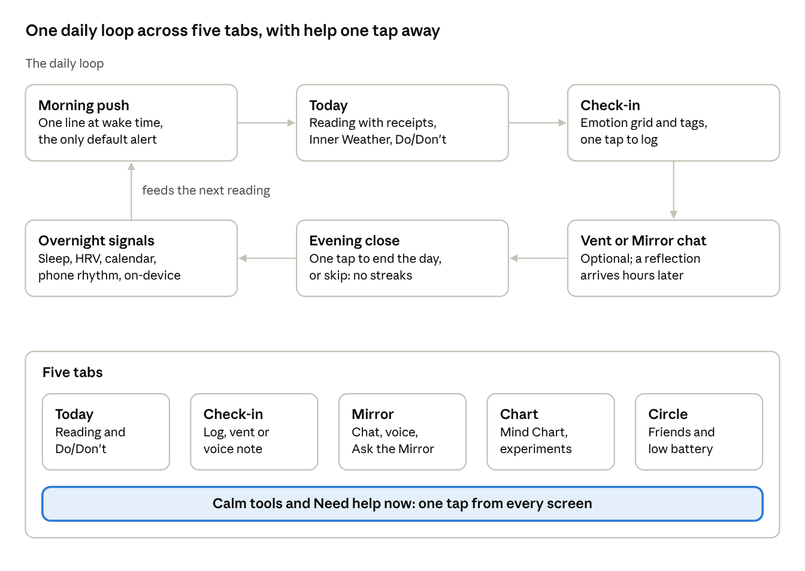
app structure · daily loop and five tabs
Progressive unlocks keep the app simple at first: Today and Check-in on day 1, Mirror chat on day 3, patterns on day 7, the Mind Chart on day 14, Wrapped after day 30.

8. Safety, privacy and regulation
Stay a general-wellness reflection tool, and build crisis handling and privacy to the strictest 2026 state standard from the first release. Woebot spent $124M chasing FDA authorisation and shut its consumer app in June 2025 (STAT); Ash left the UK in January 2026 for lack of a regulatory path. This section is a product brief, not legal advice: have a health-tech lawyer review it before launch.

Where the legal line sits
- FDA: low-risk generative AI for coaching or general wellness may fall under enforcement discretion; autonomous therapy or diagnosis falls within FDA oversight, and no generative-AI mental health device has been authorised (Hogan Lovells on the Nov 2025 advisory committee). Marketing claims decide which side you're on.
- Words to never use in the product or marketing: treat, therapy, therapist, diagnose, depression/anxiety detection, clinical outcomes. Allowed: reflect, notice, patterns, wellbeing, self-awareness.

2026 US state chatbot laws
State | Rule | What MirrorSpace must do
Illinois, Nevada, Rhode Island, Maine | Ban AI from delivering therapy to the public (Quartz) | Never present Mirror chat as therapy; wellness framing everywhere
Colorado | Prohibits AI therapy chatbots; limits how licensed providers use AI (Quartz) | Same; review the clinician view before any B2B launch there
California SB 243 (effective Jan 1, 2026) | Disclose non-human status, crisis protocols, minor protections (Orrick) | AI disclosure, crisis flow, 18+ gate
Oregon SB 1546 (signed March 2026) | Disclosure, suicidal-ideation detection, crisis-referral interruptions, annual filings, minor measures (Orrick) | Detection pipeline + interruption screen + yearly report
Utah | Mental-health chatbots must disclose AI and protect user data (Quartz) | Disclosure + no data sale or ad use
New York, Nebraska | Disclosure, crisis referral, minor protections for companion bots | Covered by the same controls
More than 70 chatbot bills were introduced in 36 states in Q1 2026 alone, so design to the strictest rule, not the current map.

Crisis protocol (MVP requirement)
- Detect: on-device classifier screens every check-in, vent and chat message; server-side LLM classifier double-checks flagged text; keyword list as a backstop.
- Tier the response: low concern → gentle check-in line; elevated → interruption screen with grounding and helplines; acute → full-screen crisis card, one-tap call or text, safety plan, and the AI stops reflective replies.
- Localise helplines: 988 (US), Tele-MANAS 14416 (India), Samaritans 116 123 (UK), and a maintained list for other launch countries.
- Log without reading: store only event counts and tiers for the annual Oregon-style report; no human reads journals.
- Test: monthly red-team suite of crisis and edge-case prompts across models; track miss and false-alarm rates.
- Advise: a clinical advisory board (a psychologist and a psychiatrist to start) signs off on prompts and crisis flows.

Privacy
- Precedent: the FTC fined BetterHelp $7.8M and banned it from sharing health data for ads after it passed health answers to Facebook and Snapchat (FTC). No ad SDKs, no pixel tracking, ever.
- India: the DPDP Rules were notified on Nov 13, 2025; the main duties (notice, security, 72-hour breach notice) apply from May 13, 2027 (PIB). Build standalone consent screens now.
- EU/UK: health data is special-category under GDPR; explicit consent and a DPIA are needed before launch there.
- US: the FTC Health Breach Notification Rule and Washington's My Health My Data Act apply to consumer health apps even outside HIPAA; HIPAA applies only once working with covered entities (B2B).
- Architecture: journals end-to-end encrypted with keys on the device; sentiment and crisis pre-screening on-device; only derived features sent to the server; self-hosted product analytics with no content; configurable retention; one-tap export and delete; SOC 2 Type I before the first B2B deal.
- Minors: 18+ at launch. A teen version needs its own legal review and parental-consent design.

9. Technical architecture
Rebuild the client in React Native with Expo and keep the Node backend, refactored around a pattern engine that turns signals into facts before any LLM sees them. Expo reuses the team's React skills and gives HealthKit, Health Connect, widgets, notifications and store builds from one codebase.
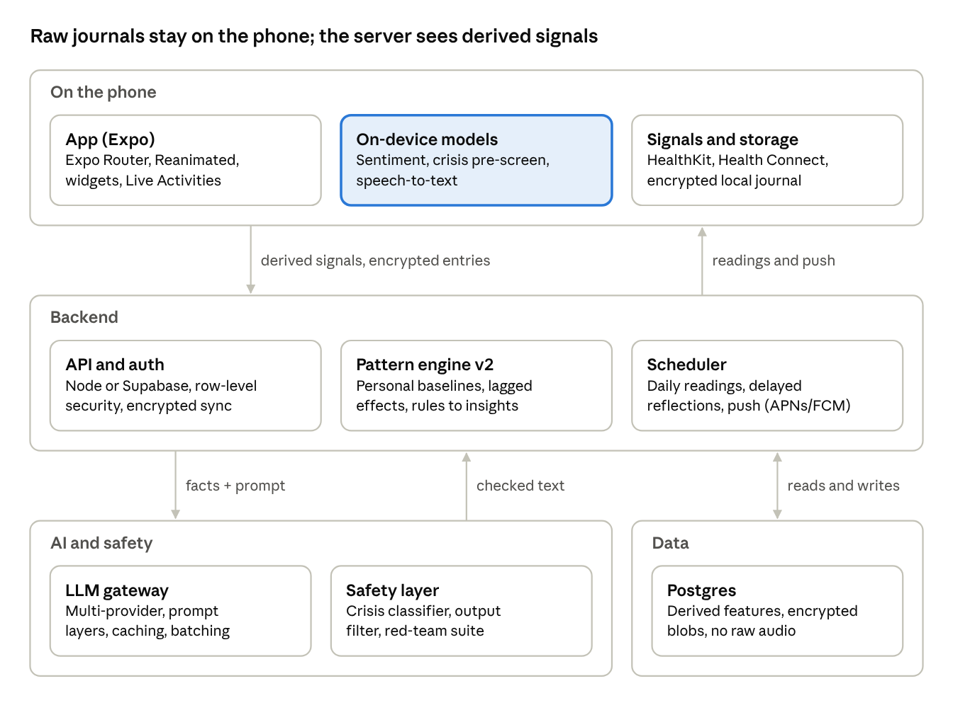
technical architecture · phone, backend, AI, data
The LLM only writes the words; the pattern engine decides what is true. That keeps receipts honest, cuts hallucination and cost, and keeps raw text off the server.
Layer | Choice | Notes from the current repo
Mobile | Expo (React Native), Expo Router, Reanimated/Moti, react-native-health / Health Connect, expo-notifications, widgets | Port the framer-motion ambient visuals (GradientOrbs, ParticleField) and design tokens
Local data | SQLite with SQLCipher or MMKV (encrypted); keys in Secure Enclave / Keystore | New: journals move off the server by default
On-device ML | Small sentiment and crisis classifiers (Core ML / TFLite), on-device speech-to-text | Replaces server-side sentiment for raw text
API | Express 5 (existing) or Supabase (Postgres, auth, row-level security, edge functions) | Existing routes: auth, calm, chat, insights, journal, patterns, sleep, user
Pattern engine v2 | 30-day personal baselines (z-scores), lagged correlations (sleep → next-day mood), minimum-data thresholds, rule-based insight facts | Upgrade of patternEngine.js, which today averages sentiment over 7 days
AI gateway | One module for all providers with fallback, prompt caching, batched daily readings | Merge the duplicated generateAIResponse in reflectionEngine.js and insightGenerator.js; keep personality.js prompt layering
Safety | Input and output classifiers, crisis tiering, region rules, red-team CI job | New; required before launch
Jobs | Queue (BullMQ or Supabase cron) for readings at each user's wake time and delayed reflections | Delayed reflections exist but need a real scheduler
Analytics | Self-hosted product analytics with event names only, no content | New
Testing | Jest + React Native Testing Library, Detox or Maestro end-to-end, prompt eval suite | Repo has no tests yet
Core data model additions: CheckIn (emotion, energy, pleasantness, tags), SignalDay (sleep window, HRV, steps, calendar load, phone rhythm), Baseline, InsightFact (claim, evidence ids, confidence), Reading (headline, receipts, do/don't), Friendship and Circle (consent scopes), Experiment, Letter, SafetyEvent (tier and timestamp only), MemoryItem (user-editable).

10. Business model
Freemium consumer subscription first, B2B second, never ads or data sales. Price below Rosebud ($12.99/mo) and Co-Star Pro-Star ($8.99/mo) to answer the category's pricing backlash; Finch shows a kind, free core can still earn about $2M a month.
 | Free | Pro
Daily reading, Do/Don't, Inner Weather | Yes | Yes
Check-ins, vent, delayed reflections | Yes | Yes
Calm tools, crisis help, safety plan | Yes (never paywalled) | Yes
Data export and deletion | Yes (never paywalled) | Yes
Receipts | Headline only | Full detail
Mind Chart | Basic (3 traits) | Full, monthly updates
Mirror chat | 10 messages / day | Unlimited, voice mode
Ask the Mirror | — | Yes
Friends and circles | 1 friend | Unlimited friends and circles
Experiments, Wrapped, letters to future self | Wrapped only | All
Therapist summary | — | Yes
Proposed prices (to test): US $6.99/month or $49.99/year; India ₹149/month or ₹999/year via UPI; 50% student discount; hardship pricing on request. A/B test the annual price before launch.
B2B paths, in order:
- Universities (month 9+): campus licences bundled with counselling-centre referrals; students are the launch audience anyway.
- Therapists (month 12+): clinician view at a per-seat monthly fee; clients keep control of what is shared. Requires HIPAA readiness and BAAs.
- Employers (later): anonymised, aggregate wellbeing signals only; never individual data to an employer.
Unit-economics guardrail: keep AI inference below 15% of revenue per paying user by generating daily readings in one batched call per user, caching the personality prompt, running classification on-device, and using a smaller model for routine replies. Assumption to validate in the pilot: free-to-paid conversion of 3–5%, typical for consumer health subscriptions.

11. Go-to-market and startup lessons
Win one narrow group first: university students aged 18–25, in India and the US, growing through shareable readings and friend invites. This follows Paul Graham's advice to find "a subset of the market in which you can get a critical mass of users quickly" (Do Things That Don't Scale).

Lessons from Y Combinator and funded peers
Lesson | Evidence | What MirrorSpace does
Recruit the first users by hand | PG: "You can't wait for users to come to you" (essay) | Founders onboard the first 100 users personally on 2–3 campuses
Delight early users intensively | PG: first users should feel joining was "one of the best choices they ever made" | Founders review the first 1,000 daily readings for quality and tone
Grow ~10% a week | Same essay | Weekly growth target from week 4; invite loop tied to compatibility
"Know why you feel this way" is a fundable pitch | Stoic (YC S19) pitched understanding, not fixing | Lead with receipts and patterns, not promises
Most recent YC mental-health bets are clinical or B2B | Of 33 YC mental health startups, consumer tracking apps are few (Stoic, Sayana); peer support (7 Cups, S13) and clinician tools dominate | Show strong retention data before applying; keep the B2B story ready
Peer support retains best | Peer-support apps had the highest 30-day retention (8.9% median) (Baumel 2019) | The social layer ships in v1, not "later"

Launch playbook
- Pre-launch waitlist: "Get your Mind Chart" landing page; referral position boost; target 5,000 sign-ups.
- Campus pilot: 2–3 campuses, student ambassadors, a counselling-centre partner for referrals and the research pilot.
- Share loop: story-sized reading cards and Chart snapshots with a subtle watermark; compatibility requires the friend to join (Co-Star's loop).
- Content: short-form videos of real readings (with consent) and the "anti-streak" stance; partner with mental-health-literate creators, not generic influencers.
- App store: list under Health & Fitness; keywords "mood journal", "mood tracker", "self-reflection", "sleep and mood"; avoid "therapy".
- Press: "the mental health app that shows its receipts"; publish the pilot results.

Accelerators and funding to target
- Y Combinator (apply with 8 weeks of retention data).
- India: government startup schemes and health-focused incubators for the Hinglish and campus wedge.
- Angels from consumer health (Calm, Headspace, Finch alumni) and mental-health-focused funds.

12. Roadmap
MVP in about 10 weeks, a campus beta over winter, public v1 in spring 2027. Each phase opens only when its gate's numbers are met; dates slide, gates don't.
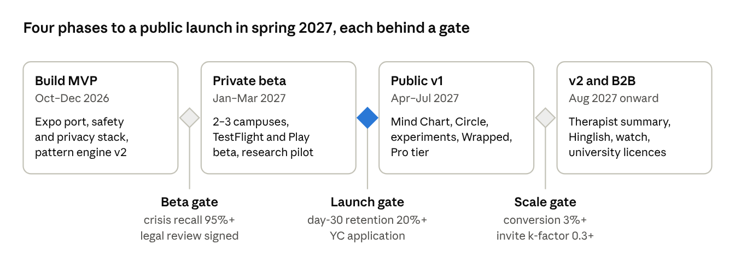
roadmap · 4 phases, 3 gates
MVP scope (Build MVP phase): Expo app with onboarding, Today (reading, receipts headline, Inner Weather, Do/Don't), one-tap check-in and widget, Vent with delayed reflection, Mirror chat, HealthKit / Health Connect sleep, calm tools, crisis protocol, AI disclosure, encrypted local journal, export and delete. Everything else in sections 4 and 5 is tagged v1 or v2. India's DPDP main duties start May 13, 2027, inside the Public v1 phase, so consent screens ship with the MVP.

13. Metrics, risks and open questions
North-star metric: reflective days per user per week (days with the reading opened plus a check-in, vent or chat). Targets below are goals to test, set against a category median of 3.3% at day 30.
Metric | Target at v1 | Why
Day-1 / day-7 / day-30 / day-100 retention | 45% / 30% / 20% / 12% | Retention is the category's unsolved problem
Reflective days per week | 4+ | Habit strength without streak pressure
Check-in completion time | Under 10 seconds median | Keeps effort near zero
Share rate | 10% of weekly users share a card | Co-Star-style growth
Invite k-factor | 0.3+ | Compatibility and circles drive invites
Free-to-paid conversion | 3–5% | Business viability
Crisis detection recall (red-team set) | 95%+, with false alarms tracked | Legal and ethical floor
Emotional self-awareness change (pilot) | Significant pre/post gain | Evidence for B2B and press

Risks
Risk | Likelihood | Mitigation
New state or country law restricts AI chat | High | Wellness framing, strictest-rule compliance, chat can be switched off by region
AI says something harmful | Medium | Layered safety, red-team suite, advisory board, short reflective replies only
Data breach | Medium | End-to-end encryption, on-device processing, minimal server data, SOC 2
Users stop after week 2 | High | Passive signals, low-day mode, social layer, Chart unlocks at day 14
Spurious or wrong insights erode trust | Medium | Personal baselines, minimum data thresholds, receipts, "this doesn't fit" feedback button
iOS limits on screen-time and background data | High | Treat as optional; build the core on HealthKit and check-ins
An incumbent copies the reading format | Medium | Speed, voice, social graph and privacy stack are slower to copy than a UI
Look-and-feel claim from Co-Star | Low | Distinct visuals, names and metaphors (section 6); legal review
AI cost grows faster than revenue | Medium | Batching, caching, on-device and smaller models

Open questions
- ☐ Launch first in India, the US, or both at once?
- ☐ iOS-first, or iOS and Android together (Expo makes both feasible)?
- ☐ Is "MirrorSpace" clear for trademark in the launch countries?
- ☐ Add a clinical co-founder or advisor before the pilot?
- ☐ Which LLM provider(s) meet the privacy terms (no training, data residency)?
- ☐ Which university will host the research pilot?

14. Sources
Research done on September 29, 2026. Pages under "Opened and read" were fetched in full. The rest were checked through search-result abstracts and summaries (several journal sites blocked automated reading); open them before quoting any figure to investors.
Opened and read
- Midjourney acquired Co-Star (TechCrunch, Jul 2026)
- Woebot shuts down its app (STAT, Jul 2025)
- Rosebud product and pricing
- Mental Health Tech startups funded by Y Combinator
- YC-backed Stoic (TechCrunch, 2019)
- Paul Graham, Do Things That Don't Scale
Peer-reviewed research (abstracts and summaries)
- Heinz et al. 2025, Randomized Trial of a Generative AI Chatbot for Mental Health Treatment, NEJM AI and critical letter
- Digital phenotyping methods in depression, systematic review, ScienceDirect
- Smartphone digital phenotyping in Korean community settings, ScienceDirect
- Predicting mood episodes from wearable sleep and circadian features, npj Digital Medicine 2024
- JITAIs for mental health, systematic review and meta-analysis 2025
- Baumel et al. 2019, Objective User Engagement With Mental Health Apps, JMIR
- Frattaroli 2006, Experimental Disclosure and Its Moderators, Psychological Bulletin and review of meta-analyses, European Psychologist
- Lieberman et al. 2007, Putting Feelings Into Words, Psychological Science
- Kauer et al. 2012, Self-monitoring in early adolescent depression, JMIR
- MoodPrism engagement study, Journal of Affective Disorders
Market and competitors
- Midjourney buys Co-Star (Startup Fortune)
- How the design of Co-Star is conquering the masses (Medium)
- Headspace Ebb
- Slingshot AI launches Ash (HLTH) and Ash review 2026
- Stoic features
- Daylio (Wikipedia)
- Bearable
- How We Feel (Yale Medicine)
- Finch features and Sensor Tower estimates
- Apple Health mental health assessments
- What users say about wellbeing apps 2026 (Unstar)
Regulation, privacy and IP
- 2026 State Chatbot Laws (Orrick)
- State laws restricting AI in mental health care (Quartz)
- FDA advisory committee on generative AI mental health devices (Hogan Lovells)
- FTC order against BetterHelp
- India DPDP Rules 2025 (PIB)
- Mozilla: mental health apps fail at privacy
- Legal protection of UI/UX design (Lexology)

